**GAS LEAKAGE MONITORING AND ALERTING SYSTEM FOR INDUSTRIES**

**COMPONENT USED:**

**1.** ARDUINO

**2.** 16X2 DISPLAY

**3.** ULTRASONIC SENSOR

**4.** PIR SENSOR

**5.** GAS SENSOR

**6.** PHOTORESISTOR

**7.** RELAY

**8.** BULB

**9.** DC MOTOR

**10.** SLIDE SWITCH

**SOFTWARE USED:**

TINKERCAD

**CIRCUIT DESIGN:**

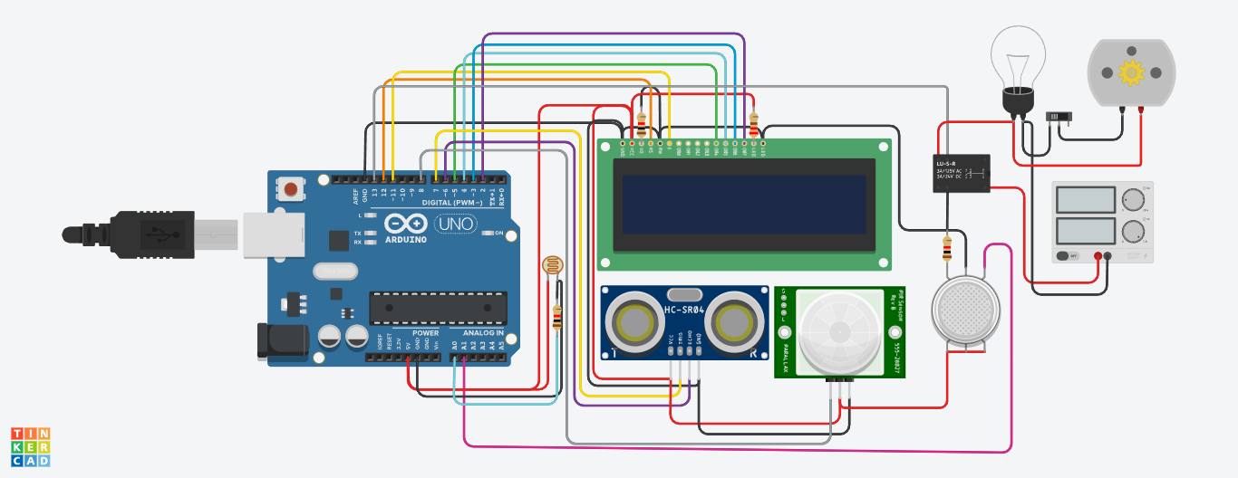

**CODE**

 //include the library code:

#include <LiquidCrystal.h>

// initialize the library with the numbers of the interface pins

LiquidCrystal lcd(12, 11, 5, 4, 3, 2);

//For ultrasound sensor

int distanceThreshold = 0;

int cm = 0;

int inches = 0;

//for Relay Control

int releNO = 13;

int inputPir = 8;

int val = 0;

int resuldoSensorLDR;

int sensorLDR = A0;

//For Gas sensor

int const PINO_SGAS = A1;

long readUltrasonicDistance(int triggerPin, int echoPin)

{

  pinMode(triggerPin, OUTPUT); // Clear the trigger

  digitalWrite(triggerPin, LOW);

  delayMicroseconds(2);

  // Sets the trigger pin to HIGH state for 10 microseconds

  digitalWrite(triggerPin, HIGH);

  delayMicroseconds(10);

  digitalWrite(triggerPin, LOW);

  pinMode(echoPin, INPUT);

  // Reads the echo pin, and returns the sound wave travel time in microseconds

  return pulseIn(echoPin, HIGH);

}

void setup() {

  // set up the LCD's number of columns and rows:

  lcd.begin(16, 2);

  pinMode(releNO, OUTPUT);

  pinMode(inputPir, INPUT);

  pinMode(sensorLDR, INPUT);

  Serial.begin(9600);

}

void loop() {

  // set threshold distance to activate LEDs

  distanceThreshold = 350;

  // measure the ping time in cm

  cm = 0.01723 * readUltrasonicDistance(7, 6);

  // convert to inches by dividing by 2.54

  inches = (cm / 2.54);

    lcd.setCursor(0,0); // Sets the location at which subsequent text written to the LCD will be displayed

  lcd.print("D:"); // Prints string "Distance" on the LCD

  lcd.print(cm); // Prints the distance value from the sensor

  lcd.print("cm");

  delay(10);

    val = digitalRead(inputPir);

  resuldoSensorLDR = analogRead(sensorLDR);

  if(resuldoSensorLDR<600)

  {

    if(val == HIGH)

    {

      digitalWrite(releNO, HIGH);

      lcd.setCursor(0,1);

  lcd.print("L: On ");

      delay(5000);

  }

    else{

      digitalWrite(releNO, LOW);lcd.setCursor(0,1);

  lcd.print("L: Off");

      delay(300);

  }

}

  else{ digitalWrite (releNO, LOW);

  Serial.println(resuldoSensorLDR);

  delay(500);

  }

  int color = analogRead(PINO_SGAS);

  lcd.setCursor(8,0);

  //lcd.print("");

  if(color <= 85){

    lcd.print("G:Low ");

  } else if(color <= 120){

    lcd.print("G:Med ");

  } else if(color <= 200){

    lcd.print("G:High");

  } else if(color <= 300){

    lcd.print("G:Ext ");

  }

  delay(250);

}

**DESIGN AND SIMULATION LINK**

<https://www.tinkercad.com/things/6iiS4lJUiVS>